BLOGS, SOCIAL MEDIA, NEWSLETTER OR EMAIL ARTICLE
Written 31 March 2020

UNIVERSAL CREDIT (UC) FACT SHEET FOR CLIENTS

Introduction for 2020 members:
This is an area many of you will not have needed to know about but with many individuals falling into UC and the world of State Benefits (as a result of the Pandemic) we thought we can direct you to where you can find the information you require. If this is not your area of expertise then refer your clients to the fact sheet and the Government web pages detailed below.

It is a fact of the matter that we must focus on businesses that are “fundamentally sound and normally viable” – we cannot now deal or advise every client, there is simply not enough time in the day or week to become experts in areas such as UC. We can be empathetic to clients in need of UC and do our best to direct them to the information they need.

We advise using the text to deal with client queries and to post on your web site as background information or blog or social media. The copy is 27 pages long and is current 31 March 2020.

UNIVERSAL CREDIT (UC) FACT SHEET FOR CLIENTS

The following information can be found at: http://www.understandinguniversalcredit.gov.uk/new-to-universal-credit/how-much-youll-get/

We have summerised this into several sections and we hope you find the information useful.

How your UC payment is calculated:

There are 3 steps to work out your Universal Credit payment. More details about each stage are below:

- Your household’s maximum Universal Credit amount is calculated. This will be made up of one standard amount and any additional amounts that apply to you and your household (for example, for housing costs or children).
- Money may then be taken off because of your earnings or other income (such as money from savings), to pay back any advances or loans you have taken out, or because arrangements have been made for money to go straight to your utility provider. If you have received a sanction, this will also reduce your Universal Credit payment.
- If it applies to you, the benefit cap may reduce how much you receive.
What makes up your payment

Standard allowance

Part of the Universal Credit payment is a standard amount for your household. This is known as your standard allowance. Your monthly amount will depend on whether you are single or in a couple, and your age.

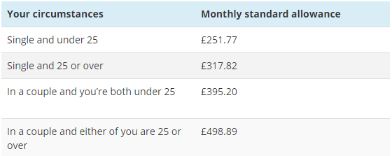

Children and childcare
Universal Credit can provide support to help with the costs of bringing up children. The amount you may be able to get is shown here, and there’s more detail in the section on:

https://www.understandinguniversalcredit.gov.uk/new-to-universal-credit/children-and-childcare/
Child amount:

If you are responsible for a child (or children) who normally lives with you, you may qualify for the child amount:
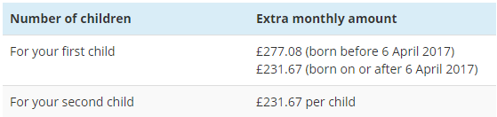

Disabled child amount
You may get extra money if your dependent child is disabled. This Disabled Child Addition is paid at either a higher rate or a lower rate.

To qualify for the lower rate your child must be:
- entitled to Disability Living Allowance, or
- entitled to Personal Independence Payment (for a child over 16)
To qualify for the higher rate your child must be:
- entitled to Disability Living Allowance (higher rate care component)
- entitled to Personal Independence Payment (enhanced rate) (for a child over 16), or
- registered blind
You can still receive a disabled child addition for a third or subsequent child, even if you do not get the basic child amount.
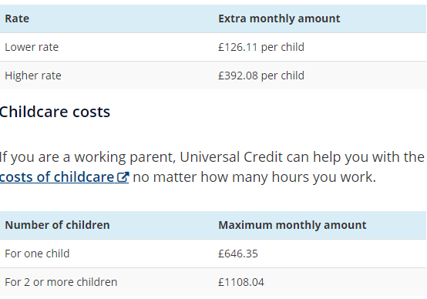

Carer’s amount
You can get an additional amount if you are caring for a severely disabled person for at least 35 hours a week. You do not need to be in receipt of Carer’s Allowance. If you make a joint claim, both of you can get a carer’s amount as long as you are not caring for the same severely disabled person.

If you or your partner get Carer’s Allowance, your Universal Credit payment will be reduced by £1 for every £1 you receive from Carer’s Allowance.

If you are entitled to both the carer’s amount and the ‘limited capability for work’ or ‘limited capability for work and work-related activity’ amount (see below for more information), you won’t receive both. Instead you will receive the larger amount.


Limited capability for work amount
If you have a condition that means you aren’t able to look for work now but can prepare for work with the aim of working at some time in the future, you won’t usually be able to get any additional amounts of Universal Credit due to sickness or disability. However, you may get an additional amount if:
- you have been assessed previously as having limited capability for work
- you were receiving a benefit because of that condition before 3 April 2017
- you still have that condition
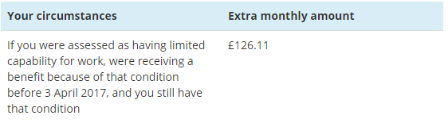

Limited capability for work and work-related activity amount
You can get an additional amount if you have a health condition or disability that affects your ability to carry out work-related activity. This is assessed through a Work Capability Assessment, see: https://www.understandinguniversalcredit.gov.uk/new-to-universal-credit/health-conditions-or-disabilities/

If you are making a joint claim and you both are entitled to this addition, your payment will only include one amount.

You may have to wait 3 months for your limited capability for work and work-related activity amount to be added to your Universal Credit payment. There are instances where it can be added on straight away, such as if you were entitled to Employment and Support Allowance immediately prior to your Universal Credit claim.

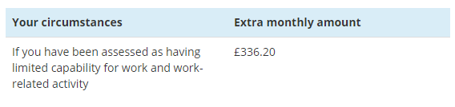
If you’re terminally ill you may get extra money from Universal Credit.

Find out more about how Universal Credit can help people with heart conditions or disabilities:
https://www.understandinguniversalcredit.gov.uk/new-to-universal-credit/health-conditions-or-disabilities/

Housing costs
If you and/or your partner are responsible for paying rent (including some service charges) for the home you live in, or if you have a mortgage, Universal Credit may provide help towards the cost.

If you receive help towards housing costs it will be paid as part of your Universal Credit payment. It is your responsibility to make sure you pay your rent and other housing costs to your landlord in full.

If you are having trouble managing your money, or if you live in Scotland, you can ask to have your housing costs paid straight to your landlord.

See: https://www.understandinguniversalcredit.gov.uk/already-claimed/helpline/
Contacting Universal Credit:

Use your online Universal Credit account to get in touch with the Department for Work and Pensions. Sign into your Universal Credit account: https://www.gov.uk/sign-in-universal-credit
You can call the Universal Credit helpline to get help making your claim online or if you need help applying for an advance payment.

- Telephone: 0800 328 5644
- Textphone: 0800 328 1344
- Welsh language: 0800 328 1744
- Monday to Friday, 8am to 6pm

There are large queues to get through just now, so it is a case of patience and perseverance.

Earnings and other income
Other money coming into your household will be taken into account when working out your Universal Credit payment. This includes your earnings, any capital you have and any other sources of income (such as from a retirement pension).

Earnings
You may still be able to receive Universal Credit payments when you start work or increase your earnings. Your Universal Credit payments will adjust automatically if your earnings change, meaning you have the flexibility to take on part-time or short-term work.
As your earnings increase, your Universal Credit amount will go down, depending on your circumstances. For more information see: https://www.understandinguniversalcredit.gov.uk/new-to-universal-credit/universal-credit-and-work/

If you are part of a couple and have a joint award, then both your earnings will be used to calculate your Universal Credit payment.

Capital
Capital is something that could be a source of income. This includes:
- savings, such as those in a bank or building society
- investments such as Bonds or ISAs
- property that you may own or part own (other than the house you live in)
When you claim Universal Credit, you will need to declare all of your capital. If your capital is worth more than £16,000 you will not be entitled to claim Universal Credit. If you are in a couple but have to make a claim as a single person, your partner’s capital/savings will still be taken into account.

Here’s how the amount of capital you have will affect your Universal Credit claim: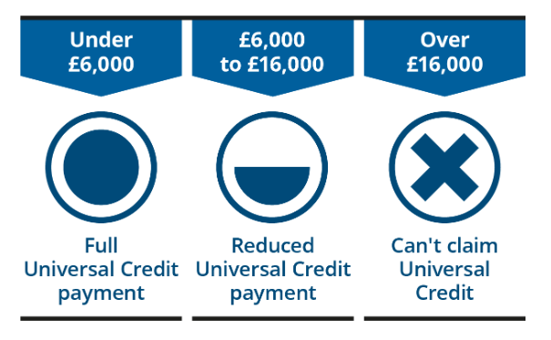

- Any capital/savings you have under £6,000 is ignored.
- Any capital/savings you have worth between £6,000 and £16,000 is treated as if it gives you a monthly income of £4.35 for each £250, or part of £250, regardless of whether it does or not. So, if you have £6,300 in a savings account, £6,000 of it will be ignored and the other £300 will be treated as giving you a monthly income of £8.70.
- If you have capital/savings worth more than £16,000 you will not be entitled to Universal Credit. This is the same if you are a single claimant or are making a claim as a couple.
Other money coming into your household
This means any other money that you may receive, for example, from a pension or other benefits.

When you claim Universal Credit, you need to tell us about your income from other sources as this could affect the amount of Universal Credit you receive. These include:
- Retirement pension income
- Maintenance payments
- Student income
- Any other income which is taxable
You can be getting other benefits and also receive Universal Credit at the same time. For every £1 you receive from them, your Universal Credit payment will be reduced by £1. These include:
- Carer’s Allowance
- Incapacity Benefit
- Maternity Allowance
- New style Employment and Support Allowance
- New style Jobseeker’s Allowance
When working out your Universal Credit, there are some other benefits that aren’t taken into account. These include:
- Child Benefit
- Disability Living Allowance
- Personal Independence Payment
- war pensions
More information is available at: https://www.gov.uk/universal-credit/what-youll-get
Deductions

Money may be taken out of your Universal Credit payment:
- to pay back any advances or loans you have taken out
- to pay back any debt or overpayment on other benefits
- to pay your utility bills direct to the provider
- for child maintenance payments
The maximum amount of money that can normally be taken out of your payment for these reasons is 30% of your standard allowance.

Your payment may also be reduced if you have received a sanction. See: https://www.understandinguniversalcredit.gov.uk/already-claimed/sanctions/

This can be up to 100% of your standard allowance if you are claiming on your own, or up to 50% of the standard allowance for each member of a couple.

If you used to claim tax credits and you received an overpayment, this debt will be carried over to Universal Credit. Your Universal Credit payments will be reduced until the overpayment has been paid back.

Read more about debts and deductions that can be taken from Universal Credit payments: https://www.gov.uk/guidance/universal-credit-debt-and-deductions-that-can-be-taken-from-payments

Benefit cap
There’s a limit on the total amount of benefit that most people aged 16 to 64 can get. This is called the benefit cap, and how much it is depending on your circumstances.
If you live outside Greater London (See: https://directory.londoncouncils.gov.uk/)

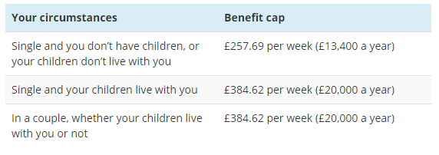
If you live in Greater London:
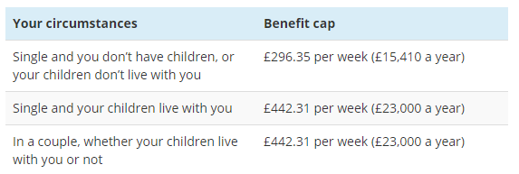

Help towards the cost of supported or sheltered accommodation isn’t counted when working out the total amount of benefit you receive.

If you are already claiming benefits and are likely to be affected by the benefit cap rules, you will already have been notified and offered support from a work coach to help you prepare for it.

The benefit cap will not apply to some people – for example, if you or your partner work more than a certain number of hours per week. Find out more about the benefit cap: https://www.gov.uk/benefit-cap

GETTING PAID
Universal Credit is a single payment that is paid monthly, although you may have to wait for around 5 weeks for your first payment. You may be able to get a Universal Credit advance if you are unable to manage during this period: https://www.understandinguniversalcredit.gov.uk/new-to-universal-credit/help-with-managing-your-money/

If you are having trouble managing your money you may be able to be paid more frequently, such as twice a month.

Your Universal Credit payment is normally paid directly into an account in your name, such as a bank, building society or credit union account. This will need to be a current account, not a savings account. If you don’t have one, the Money Advice Service website can help you choose the account that’s right for you.

If you are part of a couple, living in the same household, and both of you are claiming Universal Credit, you will receive one monthly household payment. In exceptional circumstances a Universal Credit payment can be divided between 2 members of a household. This is known as a split payment. Contact Universal Credit or talk to your work coach to find out more.
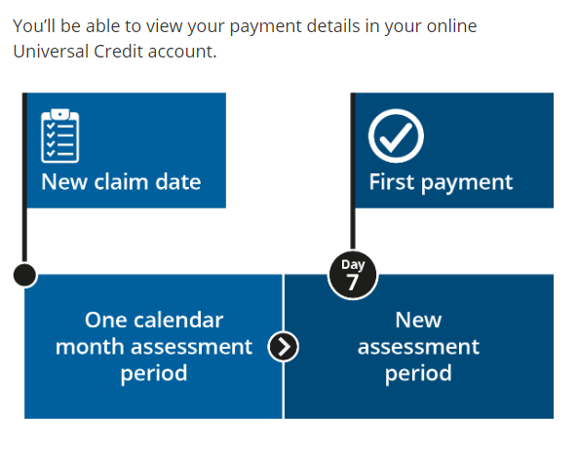
Assessment periods
Universal Credit is assessed and paid in arrears, on a monthly basis and in a single payment. Your personal circumstances will be assessed to work out the amount of Universal Credit you will get.

Your first assessment period will start on the date that you make your claim. The assessment period will last one calendar month.

You will usually receive your first payment 7 days after the end of your first assessment period. Universal Credit will then be paid on the same date each month. Your normal pay day will be fixed at 7 days after the end of your assessment period.

If your pay day is on a weekend or bank holiday you will receive your payment earlier – usually on the last working day before that weekend or bank holiday. If that would mean there is not enough time between the end of your assessment period and the day you are paid, the Department for Work and Pensions will take action to make sure you receive your payment on time.
The amount you get will not change to take account of different numbers of days in a month.
If your payment date is on the 29th, 30th or 31st of a month and the current month has fewer days, you will be paid on the last day of the month.

Example of an assessment period
The date of your new claim is 1 September.

Your first assessment period starts on 1 September.

Your assessment period then runs for a complete calendar month from 1 September to 30 September, with a new assessment period beginning on 1 October.

You will receive your first payment on 7 October. You will receive your Universal Credit payment on the 7th of each month after that.

Changes in your circumstances during an assessment period may change your payment.

If you live in Scotland
If you’re making a new claim and live in Scotland you’ll be asked if you want to get paid once or twice a month. You’ll be asked about this after you’ve received your first payment.

If you’re paid twice a month your first payment will be for a full month. You’ll get the first half of your second month’s payment a month after this. The second half will be paid 15 days later. This means there will be about a month and a half between your first payment and the full amount for your second month.

After this, you’ll be paid twice a month.

If you live in Scotland and are already claiming Universal Credit, you can ask to be paid twice a month. Ask your work coach, use your journal or call the helpline for more information.

Example of payment dates in Scotland
You get your first payment on 14 December. This payment is for a full month.

If you’re paid twice a month, you get half of your second payment on 14 January and the other half on 29 January.

You get paid on the 14th and 29th of each month after that.

HELP WITH MANAGING YOUR MONEY

Advances
If you have made a Universal Credit claim but are unable to manage until your first payment, you may be able to get a Universal Credit advance.

The amount you can borrow will be up to your first estimated Universal Credit monthly payment.
You will need to pay back your advance a bit at a time from your future Universal Credit payments. You will usually pay your advance back over a 12 month period.

To apply for an advance payment, you’ll need to:
- let the Department for Work and Pensions know why you need the advance
- provide your bank details so that the money can be paid if an advance is agreed
- have had your identity checked at the jobcentre (unless you are affected by coronavirus)
- show that you can pay it back
- agree to pay it back
You will usually be told if you can get an advance on the same day that you apply for it.
You can apply for an advance payment in your online account. You can also call the Universal Credit helpline or speak to your work coach.

You can only apply for an advance online if you are within your first Universal Credit assessment period and you have had an interview at the jobcentre. However, if you are affected by coronavirus you can receive up to a month’s advance up-front without physically attending a jobcentre.

You may be able to get an advance after your first assessment period if you have had a change of circumstances that means you will get a larger Universal Credit payment, but you haven’t yet received that increased amount. If you are in this situation you can apply for an advance by calling the helpline:
- Telephone: 0800 328 5644
- Textphone: 0800 328 1344
- Welsh language: 0800 328 1744
- Monday to Friday, 8am to 6pm

Managing your money
Universal Credit is paid as a single monthly payment. It will usually be up to you to pay your rent and bills for the month using this money.

You may be used to managing your money on a monthly basis, but if not you will need to make sure you can pay all your bills from this single payment. In most cases this will include paying your own rent and other housing costs.

Budgeting support
A range of support services are available to help you budget. You can talk to your work coach about the type of help you might need. Options could include an online service, advice sessions by phone, or face-to-face support.

See online money manager: https://www.moneyadviceservice.org.uk/en/tools/money-manager
Alternative Payment Arrangements

If you are having trouble managing your money whilst on Universal Credit you may be able to use an Alternative Payment Arrangement. These are changes to the way that Universal Credit is paid that can help you to pay your bills and living costs.
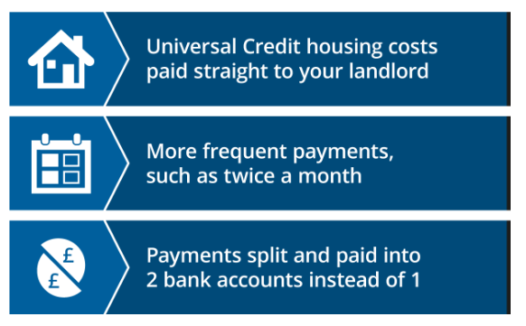
Alternative Payment Arrangements can be one or more of:
- Universal Credit housing costs paid straight to your landlord
- more frequent payments, such as twice a month
- payments split and paid into 2 bank accounts instead of one

Alternative Payment Arrangements are kept under review to make sure they are providing the right support. When one is agreed you may also be asked to take steps to help you manage your money, such as getting budgeting advice, and you will agree a review date. The purpose of that review is to decide if an Alternative Payment Arrangement is still the best approach for you.
You can ask for an Alternative Payment Arrangement at any time from your new claim interview onwards, although one can only be put in place following the end of your first assessment period. Speak to your work coach or contact the Department for Work and Pensions for more information:

https://www.understandinguniversalcredit.gov.uk/already-claimed/helpline/

YOUR RESPONSIBILITIES

Universal Credit provides financial support. In return you will be expected to do certain things, depending on your circumstances.

Changes in your situation
It is your responsibility to tell the Department for Work and Pensions about any changes in your situation, as these may mean changes to the amount of Universal Credit you receive or what is expected of you. Changes can include:
- finding or finishing a job
- having or caring for a child
- a change to your address
- becoming ill
- a change in your health condition
- a change to your banking details
- your rent payments going up or down
- a partner joining or leaving the home you rent and live in

There may be other changes that are not listed here. If there are any changes in your situation talk to your work coach or contact Universal Credit to see if they will affect your payments or what you are expected to do.

These are often called changes of circumstances. For more information see: https://www.gov.uk/universal-credit/changes-of-circumstances

Preparing or looking for work
What you are expected to do in return for receiving Universal Credit will depend on your personal circumstances. It will take into account things like caring responsibilities, or whether you are disabled or have a health condition.

With Universal Credit you usually get a work coach to help you if you are preparing for work, moving into work or looking to increase your earnings. They may continue to provide support and advice even when you start work, depending on your circumstances.

Your Claimant Commitment
In most cases what you will do will be agreed during a conversation with your work coach at the jobcentre. What you and your work coach agree will then be written down in a Claimant Commitment. This will set out what you have agreed to do to:
- prepare for work
- look for work
- increase your earnings if you are already working

Your Claimant Commitment will be reviewed regularly and may be changed if your circumstances change. Each time it changes you will need to agree and accept a new Claimant Commitment.

If you claim Universal Credit as a couple, both of you will need to accept an individual Claimant Commitment.

For more information see: https://www.gov.uk/government/publications/universal-credit-and-your-claimant-commitment-quick-guide/universal-credit-and-your-claimant-commitment

CORONAVIRUS
People receiving benefits do not have to attend jobcentre appointments for three months, starting from Thursday 19 March 2020.

- People will continue to receive their benefits as normal, but all requirements to attend the jobcentre in person are suspended.
- People can still make applications for benefits online if they are eligible.
- You should not attend the jobcentre unless directed to do so for an exceptional purpose.

If you’re already claiming Universal Credit and think you may have been affected by coronavirus, please contact your work coach as soon as possible.

UNIVERSAL CREDIT AND WORK
You may still be able to receive Universal Credit payments when you start work or increase your earnings. You will continue to receive Universal Credit payments until you are earning enough to no longer get them. That amount will depend on your circumstances.

If your job ends and you are already getting Universal Credit, your next Universal Credit payment will be paid as normal.

How earnings affect your payments
Your Universal Credit payments will adjust automatically if your earnings change. It doesn’t matter how many hours you work, it’s the actual earnings you receive that count.
If your circumstances mean that you don’t have a Work Allowance, your Universal Credit payment will be reduced by 63p for every £1 you earn.

Work Allowance
If you and/or your partner are in paid work you may be able to earn a certain amount before your Universal Credit payment starts to be affected. This is called a Work Allowance.
The Work Allowance only applies to you if:
- you have responsibility for one or more children (or qualifying young persons), or
- you or your partner have limited capability for work (a health condition or disability)
If neither of these circumstances apply to you, your Universal Credit payments will be affected as soon as you start earning money from paid work.

There are 2 Work Allowance rates. Which one you get depends on whether your Universal Credit payment includes help with housing costs:

- If you receive money to help with housing costs your Work Allowance will be £287 per month
- If you do not receive money to help with housing costs your Work Allowance will be £503 per month

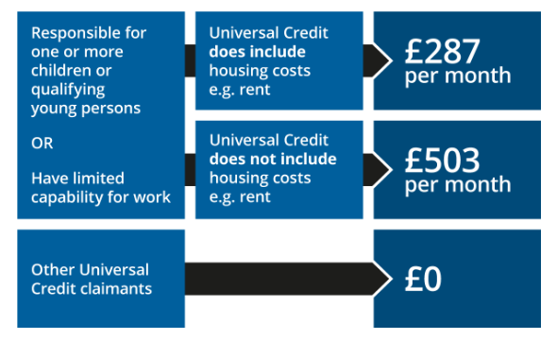
If you earn more than your Work Allowance
If you earn more than your Work Allowance, your Universal Credit payment will be reduced. For every £1 you earn above your Work Allowance, your Universal Credit payment will be reduced by 63p. This means that your total income from earnings and Universal Credit will be more than you would have received from Universal Credit alone.

If your circumstances mean that you don’t have a Work Allowance, your Universal Credit payment will be reduced by 63p for every £1 you earn.

If you are part of a couple and receive a joint Universal Credit payment, both your earnings will be used to calculate how much Universal Credit you get.

CHILDREN AND CHILDCARE

Your children
Your Universal Credit payment can include an amount to help with the costs of looking after your child or children.

Children up to the age of 16
You can now apply for Universal Credit regardless of how many children you have. If your claim is successful, your Universal Credit payment may include an extra amount of money for dependent children who normally live with you.

Who counts as a dependent child is the same for Universal Credit as it is for other benefits and tax credits. In general, if you are able to claim Child Benefit for a child then they should be included in your Universal Credit claim.

If you are making a new Universal Credit claim you will be entitled to an extra child amount for any child born before 6 April 2017. However, you will not be entitled to an extra child amount for a third or following child born on or after 6 April 2017.

You only get an extra amount for more than 2 children if:
- you were already claiming for more than 2 children before 6 April 2017
- you’re renewing a claim for more than 2 children that stopped within the last 6 months
Other special circumstances apply. Read more about the rules for families with more than 2 children. See: https://www.gov.uk/guidance/universal-credit-and-families-with-more-than-2-children-information-for-claimants

6 to 19 year old children
You may get the extra child amount for children aged 16 to 19 if they are attending or enrolled in full-time, non-advanced education or on approved training. If they are not in education or training, you will not get the extra child amount.

Disabled children
You may get extra money if your dependent child is disabled. This disabled child addition is paid at either a higher rate or a lower rate. You can receive the disabled child addition even if you don’t get the extra child amount for that child.

A change of circumstances relating to your children
If you have more children, or if one of your children leaves your home, you need to tell the Department for Work and Pensions within one month to make sure your family gets the right payment. You may get an extra child amount if, for example, you have a baby. You may stop getting the extra child amount if, for example, your child:
- leaves full-time, non-advanced education or approved training
- leaves home
- goes into local authority care (except for respite care)
- is in prison, or in custody awaiting trial or sentence
Childcare costs
If you are working, Universal Credit can help with the costs of childcare, no matter how many hours you work.
You may be able to claim up to 85 per cent of your childcare costs if you’re eligible for Universal Credit and meet some additional conditions. The amounts you can receive in childcare costs are:
- a maximum of £646.35 per month for one child
- a maximum of £1108.04 per month for 2 or more children
Childcare support is paid in arrears. This means that you will usually pay the costs yourself, and Universal Credit will then pay you some of that money back. If you think you need help with the costs at the time you pay them, you should discuss this with your work coach.

You will need to inform the Department for Work and Pensions of the cost of the childcare by the end of the assessment period after the one in which you’ve paid the childcare charges. You can do this by signing into your Universal Credit account (See above for details).

It’s important to note that you will only be paid back for childcare that has taken place during your assessment period. This means that if you pay for more than one month’s childcare in an assessment period – for example if you pay for a whole term – the money you get back at the end of that assessment period will only cover any childcare that has actually taken place during it. The rest of the payments you are entitled to will be paid in later months, once the childcare has taken place. These payments can be split over a maximum of 3 assessment periods.

If you have accepted a job offer you can claim for childcare costs for the month before you start work. Talk to your work coach as soon as possible about your job offer and the support options available. If your job ends, you must tell the Department for Work and Pensions immediately.
Support with childcare costs can be claimed for at least a month after your employment ends to help you maintain your childcare as you move between jobs.

The amount you earn can affect how much you receive from Universal Credit. If your earnings are higher than usual in an assessment period this can reduce your Universal Credit payments, including the help you get towards childcare costs. Read more about Universal Credit and work:
https://www.understandinguniversalcredit.gov.uk/new-to-universal-credit/universal-credit-and-work/

You cannot get help towards any payments that were made using childcare vouchers. If your childcare costs are higher than the value of your vouchers, you can apply for help towards that additional amount.

Earnings that are converted into childcare vouchers are not included when working out reductions to your Universal Credit payment.

How to get childcare support
You must be in paid work to receive childcare support from Universal Credit.
If you are a claiming with a partner both of you normally need to be in work to receive this help. However, you may be able to get childcare support if one of you is not working and is unable to provide childcare themselves because they:
- have limited capability for work
- have caring responsibilities for a severely disabled person
- are temporarily absent from the household
- Paid work does not include voluntary work where the only payment is expenses.
In some circumstances you can be treated as if you are in paid work while you are not working. Childcare support is available if you are claiming Universal Credit and are receiving:
- Statutory Sick Pay
- Statutory Maternity Pay
- Statutory Paternity Pay
- Statutory Shared Parental Pay
- Statutory Adoption Pay
- Maternity Allowance

You must be paying childcare costs to registered or approved childcare providers.

This generally means the childcare provider is registered with one of these organisations:
- England – OFSTED
- Scotland – The Care Inspectorate
- Wales – Care and Social Services Inspectorate for Wales (CSSIW)

Approved childcare can include care provided in school or in another place by a child minder, play-scheme, nursery or club. Your approved childcare provider should be able to provide you with a registration number.

For more information see: https://www.gov.uk/government/publications/universal-credit-and-childcare/universal-credit-childcare-guide
The Universal Credit childcare offer is part of the package of support available for parents, which may include free childcare for 15 or 30 hours a week.

For further information, please see: https://www.childcarechoices.gov.uk/ and https://www.gov.uk/government/publications/universal-credit-and-your-family-quick-guide/universal-credit-further-information-for-families

HOUSING
If you and/or your partner are responsible for paying rent for the home you live in, or if you have a mortgage, Universal Credit may provide help towards the cost. This is called Universal Credit housing costs.

Claiming housing costs
When you make a new claim for Universal Credit your housing costs will usually be paid as part of your Universal Credit payment. If you are receiving Housing Benefit, the Department for Work and Pensions will contact your local authority to stop your Housing Benefit payments. At this point you will receive an additional payment of 2 weeks’ worth of Housing Benefit to support you as you move to Universal Credit.

It is your responsibility to make sure you pay your rent and other housing costs to your landlord in full. If you are having trouble managing your money, or live in Scotland, you can ask to have your housing costs paid straight to your landlord. Talk to your work coach, use your journal or call the helpline for more information:

You can call the Universal Credit helpline to get help making your claim online or if you need help applying for an advance payment.
- Telephone: 0800 328 5644
- Textphone: 0800 328 1344
- Welsh language: 0800 328 1744
- Monday to Friday, 8am to 6pm

If you are making a new Universal Credit claim it may be 5 weeks until you receive your first payment. It’s a good idea to tell your landlord that you are claiming Universal Credit so that they understand your situation. You will need to tell them that you have made a new claim to Universal Credit and that a claim for housing costs has been included as part of your claim.

Information you need to make a claim
If you are applying for housing costs for rented property as part of your Universal Credit claim, you will need to bring evidence of how much your rent is to your new claim interview. This could be:
- a current tenancy agreement
- a current rent statement
- a current rent book, or
- a signed letter from your landlord
If you live in social rented property you won’t need to bring this information to your new claim interview. Instead you will enter details of your housing costs online, and the Department for Work and Pensions will contact your landlord to confirm that these are correct.

Types of housing costs

Mortgages
If you have a mortgage, Universal Credit may provide help towards the cost of your mortgage payments. It may also be able to help with loans (up to £200,000) you have taken out that use your property as security.
To get this help you will need to provide evidence of your mortgage or loan. This could be:
- a mortgage agreement
- a current mortgage statement
- a loan agreement, or
- bank statements showing the payment of the mortgage or loans
Help with mortgage payments or loans is provided as a loan. You will only be asked to pay back this loan if the property it was claimed for is sold or transferred to someone else. You can choose to pay the loan back early if you wish.

The Department for Work and Pensions will check your evidence before paying Universal Credit housing costs. Any delays in providing this evidence may mean delays in your Universal Credit housing costs being paid.

The amount you receive will depend on the amount of your outstanding mortgage or loans. It is calculated using a standard interest rate, and it is usually paid straight to the bank, building society or lender. You will be notified of your Universal Credit housing costs amount and payments through your online account.

You can only get help with mortgage payments if you have been claiming Universal Credit for 39 weeks or more, with no breaks or earned income in that time. Earned income can include earnings from paid work or, for example, statutory sick pay or tax rebates.

If you have moved to Universal Credit within one month of another benefit ending, time spent on the first benefit counts towards the 39 weeks.

It is important to understand that you will not be eligible for help with mortgage payments on your own home if you receive earned income. If you start receiving earned income whilst you are getting help with mortgage payments, this help will stop.

If you have a break in your claim or receive earned income you will need to claim Universal Credit for a further 39 weeks with no breaks or earned income before you can receive help with mortgage payments.

See: https://www.gov.uk/support-for-mortgage-interest

Shared ownership schemes
A shared ownership scheme is usually provided by housing associations where you part rent and part buy your home. You normally have to pay a mortgage amount and a rent amount. If you get help with this, your Universal Credit housing costs payment will include help towards your rent amount with any help towards your mortgage interest usually being paid direct to your mortgage lender.

Service charges
Some people are expected to pay a service charge on their rented property, in addition to their normal monthly rent.
If you have to pay a service charge this will be shown on your service charge statement from your landlord. Universal Credit can help towards this cost, but you will need to show evidence of any service charges that you have to pay.

Paying rent on 2 homes
Universal Credit can help towards the costs of 2 homes if:
- a family is too large to live in one home
- a family member leaves their home through fear of violence or abuse, but intends to return, or
- a family member who receives a benefit because of disability has to wait to move into their new home because it needs to be adapted for them to live in it
Types of housing
Spare bedrooms

The amount you receive towards your housing costs may be reduced if your home has spare bedrooms.

If you pay rent to a local authority, council or housing association you will get your full rent as part of your Universal Credit payment. This will be reduced by 14% if you have one spare bedroom, or 25% if you have 2 or more spare bedrooms. This is known as Removal of the Spare Room Subsidy.

Your Universal Credit housing costs may also be reduced if someone aged 21 or more lives with you who is not a dependant.

There are some exceptions to these rules – for more information see: https://www.gov.uk/guidance/local-housing-allowance

If you pay rent to a private landlord the amount of Universal Credit housing costs you receive will be worked out by looking at the number of people who live in your home. The actual size of your home doesn’t matter – the amount you get will be calculated by how many people live there. So if you have spare bedrooms you will only get housing costs to cover a smaller property. The amount you get is set by the Local Housing Allowance rate in your area.

Temporary accommodation
If you live in temporary accommodation and make a new Universal Credit claim, your payment will not include an amount to help towards your housing. You will need to claim Housing Benefit from the local authority who placed you in temporary accommodation to get help with your housing costs. You can still receive Universal Credit to help with your other costs.

If you already receive help with temporary accommodation housing costs through Universal Credit this will continue until there is a change to the amount of rent you pay. If that happens you will need to claim Housing Benefit as well as Universal Credit.

There’s more advice for people who are homeless or at risk of homelessness in: https://assets.publishing.service.gov.uk/government/uploads/system/uploads/attachment_data/file/835699/quick-guide-to-universal-credit-homeless.pdf

Supported or sheltered housing
If you live in supported or sheltered housing you won’t be able to claim housing costs through Universal Credit. Instead you can claim Housing Benefit from your local council. This will be the case even if the rest of your money comes from Universal Credit.

Paying rent to a private landlord in Scotland
In Scotland all landlords must register their properties with the local authority. If your landlord has not done this for your property you can still get Universal Credit housing costs, but you will need to let your local authority know about it. You can also speak to your work coach for more help.

Your circumstances:

If you are single and under 35 years old
If you pay rent to a private landlord and:
- are under 35
- are single
- are not disabled, and
- have no children
then your Universal Credit housing costs will be no more than if you were renting a single room in a shared house. This will be the case no matter what type of property you actually live in.
The amount you get is set by the Local Housing Allowance rate in your area: https://www.gov.uk/guidance/local-housing-allowance

There are a few circumstances in which you may be able to receive higher housing payments. Talk to your work coach or contact Universal Credit for more information.

If you are 18 to 21 years old: https://www.gov.uk/guidance/housing-costs-for-18-to-21-year-olds
If you live with someone who is 21 or older who is not your partner, your housing payment will usually be reduced. There’s more information: https://www.gov.uk/housing-and-universal-credit/renting-from-local-authority-or-housing-association

Reporting a change of circumstances
Changes to your circumstances could mean that the amount you get towards your housing costs will change. It is your responsibility to let the Department for Work and Pensions know about any changes in your situation straight away so that they can make sure you are receiving the right Universal Credit payments. Read more about things that count as a change of circumstances: https://www.understandinguniversalcredit.gov.uk/new-to-universal-credit/your-responsibilities/

Help with managing housing payments
If you are behind on your rent - If you are 2 months or more behind on your rent, your landlord can apply to have the housing costs part of your Universal Credit paid directly to them. If you fall behind on your rent you may want to talk to your landlord about this.

This is one of the ways in which Universal Credit payments can be changed to help you manage your money. To find out more see the section on Alternative Payment Arrangements.

If you are behind on your utility bills - Utility bills are for water, gas and electricity. It’s up to you to pay these out of your Universal Credit payments, and if you don’t pay them in full your suppliers could cut them off.

If you are struggling to manage your payments and are in danger of being cut off, it may be possible for part of your Universal Credit to be paid straight to your utility supplier. Talk to your work coach if you would like to know more about this.

Local Council Tax Reduction
If you receive Universal Credit you may have to pay less in Council Tax. This will depend on your circumstances and where you live. See: https://www.gov.uk/apply-council-tax-reduction
You can start the process to apply for Local Council Tax Reduction on GOV.UK. It will take you to your local council’s website, which will tell you what you need to do.

If you are claiming Universal Credit for the first time you should apply for Local Council Tax Reduction straight away, as many local councils will not backdate it for you. You do not need to wait until your claim for Universal Credit has been approved or paid.

Other help with housing payments
If changes to your benefits mean you receive less money, you may be able to get extra help towards your housing costs from your local council. These are called Discretionary Housing Payments.

You will only be able to get Discretionary Housing Payments if you receive Universal Credit housing costs and you need more help. Find out how to apply for a Discretionary Housing Payment: https://www.gov.uk/government/publications/claiming-discretionary-housing-payments/claiming-discretionary-housing-payments

HEALTH CONDITIONS OR DISABILITIES
If you have a health condition or disability which prevents you from working, or limits the amount of work you can do, Universal Credit can provide you with both financial and work-related support.

Coronavirus
In light of the current coronavirus outbreak, the Department for Work and Pensions has taken the precautionary decision to temporarily suspend all face-to-face assessments for health and disability-related benefits. This is aimed at reducing the risk of exposure to coronavirus and safeguarding the health of individuals claiming health and disability benefits, many of whom are likely to be at greater risk due to their pre-existing health conditions.

If you already have an assessment appointment arranged, you do not need to attend. Your assessment provider will contact you to discuss your appointment and explain the next steps to you.

If you have made a claim for Universal Credit but do not have a date for an assessment appointment, you do not need to do anything. You will be contacted shortly by telephone or letter to let you know what will happen next.

If you are already receiving Universal Credit you will continue to receive your current payments as normal.

Work Capability Assessments
If you say you have a health condition or disability you may be asked to attend a Work Capability Assessment to find out if your health condition or disability affects your ability to work.
There are 3 possible outcomes from a Work Capability Assessment. You will be assessed as one of the following:

- Fit for Work - This means you will be expected to look for work or to increase your earnings. You will not receive any additional amounts of Universal Credit due to sickness or disability.
- Having limited capability for work - This means that although you may be not be able to look for work now, you can prepare for work with the aim of working at some time in the future.
If you are claiming benefit for the first time and have never had a Work Capability Assessment before, you will not receive any additional amounts of Universal Credit due to sickness or disability.

However, if you were assessed as having limited capability for work, and have been continuously receiving a benefit because of that condition since before 3 April 2017, you will receive the limited capability for work amount of Universal Credit – currently £126.11 per month. You will still be able to receive this extra amount if you had a break in your claim because of earnings that lasted for less than 6 months.

- Having limited capability for work and work-related activity - This means you will not be asked to look for work, or to prepare for work.

You will get paid more Universal Credit due to your sickness or disability. You will receive the limited capability for work and work-related activity component of Universal Credit – currently £328.32 per month.

With all 3 Work Capability Assessment outcomes you may be eligible to apply for other benefits, including new style Employment and Support Allowance. Use a benefits calculator to find out what you may be able to get.

Some people may be considered to have limited capability for work or limited capability for work and work-related activity without having to attend a Work Capability Assessment.

Claiming as a couple
If you are making a claim as a couple and both of you have limited capability for work or limited capability for work and work-related activity, your joint household payment will include only one additional amount.

If one or both of you have limited capability for work and work-related activity you will receive the limited capability for work and work-related activity payment.

If you both have limited capability for work and were receiving a benefit payment due to it before 3 April 2017, you will receive the limited capability for work payment.

If you are working
If you earn more than the equivalent of 16 hours’ work per week paid at the National Minimum Wage, you will not be able to receive either the limited capability for work or limited capability for work and work-related activity payment unless you are also getting Disability Living Allowance (DLA) or Personal Independence Payment (PIP). If you are getting DLA or PIP you will still need to attend a Work Capability Assessment to assess whether you can receive this extra amount.

If your condition changes - You must let the Department for Work and Pensions know if:
- your condition has got better
- your condition has got worse, or
- you have a new health condition

If you are already getting Universal Credit and develop a health condition or become disabled, you must tell the Department for Work and Pensions as soon as possible. You won’t need to change benefits. You will stay on Universal Credit and your Claimant Commitment will be reviewed to take into account your new circumstances.
For more information about Work Capability Assessments and how Universal Credit supports people with a disability or health condition, see Health conditions, disability and Universal Credit: https://www.gov.uk/health-conditions-disability-universal-credit

Moving from Employment and Support Allowance
If you move from Employment and Support Allowance (ESA) to Universal Credit and have already been assessed as having limited capability for work or limited capability for work and work-related activity, you may not have to take the assessment again.

If you received the work-related activity component in ESA and there is no break in your claim, you will receive the limited capability for work payment in Universal Credit.

If you received the support component in ESA and there is no break in your claim, you will receive the limited capability for work and work-related activity payment in Universal Credit.

If you claim Universal Credit whilst appealing against a Work Capability Assessment decision that relates to your previous ESA claim, you will not be able to return to that ESA claim, even if your appeal is successful. You will remain on Universal Credit and any relevant changes will be made to your Universal Credit payments. Any arrears due from your time on ESA will be paid as a lump sum.

In some circumstances you may be able to receive ESA at the same time as Universal Credit, but this will be paid as new style ESA. See: https://www.understandinguniversalcredit.gov.uk/new-to-universal-credit/making-your-claim/#new-style-jsa-and-new-style-esa

For every £1 you receive from new style ESA, your Universal Credit payment will be reduced by £1.

If your Work Capability Assessment has a review date, you will need to have another assessment at that time. If your health has changed at this point this may affect whether you continue to receive a limited capability for work or a limited capability for work and work-related activity payment.

Severe disability premium
You can’t claim Universal Credit if you either:
- get the severe disability premium or are entitled to it, or
- got or were entitled to the severe disability premium within the last month and are still eligible for it
If you have a change of circumstances that affects the severe disability premium or your other benefits, report it and you’ll be told what to do next.

If you moved to Universal Credit before 16 January 2019, but were entitled to the severe disability premium in the month before you made your Universal Credit claim, you may now be able to receive a severe disability premium transitional payment.

You don’t need to take any action. If you are entitled to a transitional payment, the Department for Work and Pensions will tell you about it through your online journal.

Transitional payments will usually be a lump sum followed by ongoing monthly payments. The amount you get will depend on your circumstances.

Terminal illness
You may get extra money from Universal Credit if you’re terminally ill.

If you’re making a new claim you can declare this during your application.

If you’ve already claimed Universal Credit and are diagnosed with a terminal illness you should report this as a change of circumstances. This can be done through your Universal Credit account. You can also get someone else to report the change for you.

Find out more about benefits if you’re living with a terminal illness: https://www.gov.uk/benefits-if-youre-terminally-ill

SELF EMPLOYMENT

If you are self-employed Universal Credit may provide support.

To get this support you will need to be able to show that:
- self-employment is your main job or your main source of income
- you get regular work from self-employment
- your work is organised – this means you have invoices and receipts, or accounts
- you expect to make a profit
If you can show all these things you will be considered to be ‘gainfully self-employed’. If you can’t show all these things you might have to look for other work if you are to keep receiving Universal Credit.

How much you should get
If you are regarded as being gainfully self-employed whilst claiming Universal Credit you will not be expected to look, or be available, for other work. This will help you to concentrate on making your business a success.

However, it will be assumed that you are earning the same amount as someone like you who is in paid work. This will usually be what someone of your age would earn if they worked at the National Minimum Wage for the number of hours that you are expected to work or look for work. This amount is called the Minimum Income Floor.

If you earn less than the Minimum Income Floor, Universal Credit will not make up the difference. You may need to look for additional work to top up your income.

If you earn more than the Minimum Income Floor, your Universal Credit payment will be based on your actual earnings.

The Minimum Income Floor will not be applied for up to 12 months after you start self-employment. This is known as a start-up period, and during it you won’t need to look, or be available, for other work. But you will need to show that you are taking steps to build your business and increase your earnings when you talk to your work coach.

If you are self-employed and claiming Universal Credit, and are required to stay at home or are ill as a result of coronavirus, the Minimum Income Floor will not be applied for the period of time whilst you are affected.

From 6 April 2020 the requirements of the Minimum Income Floor will be temporarily relaxed. This change will apply to all Universal Credit claimants and will last for the duration of the outbreak. New claimants will not need to attend the jobcentre to demonstrate gainful self-employment.

You must report any earnings from self-employment to the Department for Work and Pensions every month.

For more information see: https://www.gov.uk/government/publications/universal-credit-and-self-employment-quick-guide/universal-credit-and-self-employment-quick-guide

Self-employment Income Support Scheme
The Self-employment Income Support Scheme (SEISS) will support self-employed individuals (including members of partnerships) whose income has been negatively impacted by coronavirus. The scheme will provide a grant to self-employed individuals or partnerships, worth 80% of their profits up to a cap of £2,500 per month. Read more about eligibility for SEISS: https://www.businesssupport.gov.uk/self-employment-income-support-scheme/
You should not contact HMRC about accessing SEISS now. HMRC will use existing information to check potential eligibility and invite applications once the scheme is operational.

The Self-Employment Income Support Scheme will be treated as earnings in Universal Credit. Your Universal Credit payment will adjust in response to changes in your earnings.
If you need financial help whilst waiting for SEISS, check your eligibility for Universal Credit: https://www.gov.uk/universal-credit/eligibility

Surplus earnings and losses
If you have an online Universal Credit account and are self-employed, earnings or losses from one month can be taken into account when working out how much Universal Credit you receive in a later month.

If you earn more than £2,500 over the monthly amount you can earn before you receive no Universal Credit payment, you are said to have surplus earnings. This may reduce the amount of Universal Credit you receive in later months, or perhaps mean that you can’t get any Universal Credit payment in those months.

If you make a loss in one month, the loss will be stored and taken into account in months when you make a profit. If the profits are not high enough to fully cover a loss, the remaining loss will be carried forward to the next month when you make a profit. A loss will stop being taken into account once all your losses have been accounted for or your self-employed business ends.
If you are gainfully self-employed and subject to the Minimum Income Floor, that will still apply even if you make a loss. In months where you make a loss, your Universal Credit payment will be calculated based on your Minimum Income Floor.

